DATA ANALYTICS CASE STUDY
Olist Brazilian
E-Commerce Analysis
From raw data to business decisions
Analysis of 99,441 orders across 9 business questions using Power Query, SQL, Power BI and DAX

Power Query  Cleaning | SQL Server  Validation queries | Power BI  4-page dashboard | DAX  Business measures
Dataset: Olist Brazilian E-Commerce (Kaggle) | Period: Sep 2016 – Oct 2018

01 Executive Summary
Olist is a Brazilian company that connects small merchants to large online marketplaces. This analysis answers one big question: how is the business growing, who is driving that growth, and where are the risks?
13.49M  TOTAL REVENUE  excl. canceled & unavailable | 98,207  TOTAL ORDERS  out of 99,441 | 137.41  AVG ORDER VALUE  per order | +138%  REVENUE YoY  Jan–Aug 2018 vs 2017
94,990  UNIQUE CUSTOMERS  distinct customers | 3,053  ACTIVE SELLERS  with valid sales | 4.09  AVG REVIEW  out of 5 | 12.6  AVG DELIVERY DAYS  8.1% late

Top 5 Findings
1 | Strong growth, incomplete 2018 | Revenue is up 138% on the same months of 2017, but the data ends in August 2018.
2 | Customers buy only once | 97% of customers never came back to buy again, the biggest weakness in the model.
3 | Late delivery destroys ratings | Late orders average 2.57 stars versus 4.29 for on-time orders.
4 | High geographic concentration | São Paulo (SP) alone is 41.9% of orders, and the top 3 states are 66.5%.
5 | Credit card is the backbone | 78.3% of payment value, with an average of 3.5 installments.

02 Methodology & Data Quality

Workflow
1  Power Query  Clean & transform | 2  SQL Server  Validation queries | 3  Data Model  Star schema | 4  DAX  Business measures | 5  Dashboard  4 pages

Cleaning decisions (Power Query)
Action | Reason
Fixed the misspelled product dimension column names | Consistent names that are easier to use in DAX
Removed duplicates from geolocation | The same zip prefix was repeated thousands of times
Removed 610 products with no category | They cannot be analysed by category
Dropped the two free-text columns in reviews | Mostly empty and not used in the analysis
Kept only the latest review per order | Prevents double counting when an order has several reviews
Left null delivery dates as they are | Those orders are not delivered yet; removing them would distort late-delivery rates
Left the 9 zero-value payments untouched | Genuine records with zero effect on totals

Data model
A star schema with relationships instead of one merged table: fact tables (orders, order_items, payments, reviews) connect to dimensions (customers, products + category, seller, geolocation), plus a DateTable built in DAX and marked as the date table. All measures live in a dedicated _Measures table.
TECHNICAL NOTE The customers-to-orders relationship must stay single-direction. When it was set to Both, Seller Avg Review and other measures returned blanks.

Revenue definition: Total Revenue = SUM(order_items[price]), excluding orders with status canceled or unavailable. It covers product price only, not freight.

03 Detailed Findings

Performance & trend (Q1 & Q8)
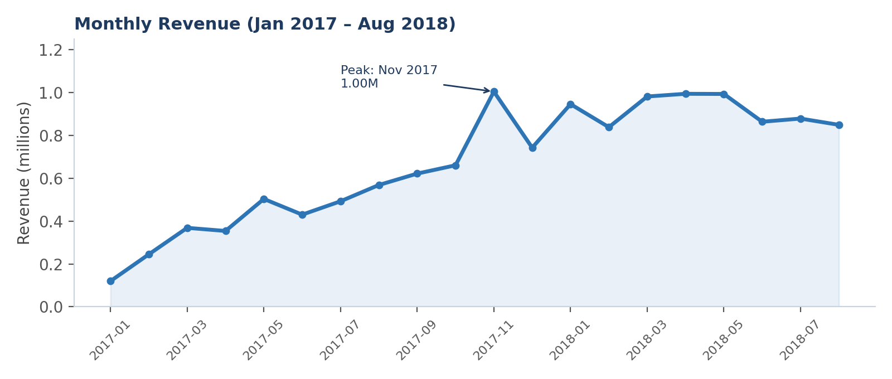
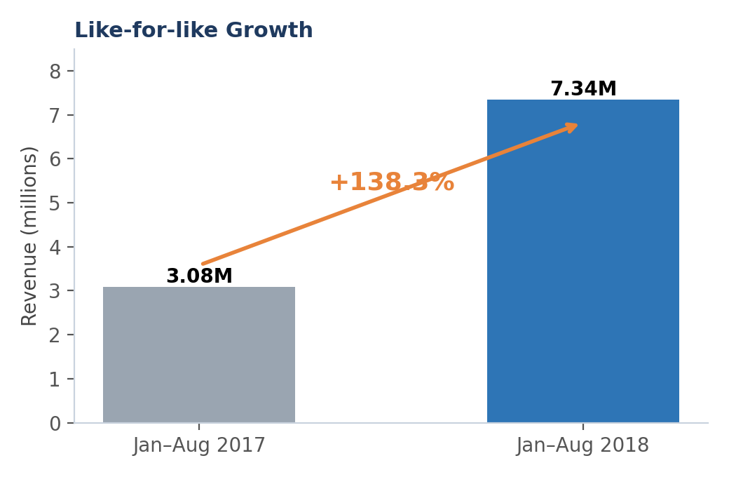
- 2017 generated 6.11M from 44,379 orders; Jan–Aug 2018 alone generated 7.34M from 53,532 orders.
- The peak month is November 2017 (1.00M), most likely driven by Black Friday; March–May 2018 are close behind.
- September 2018 contains a single order, so any "late-2018 decline" is an artefact of the data.
INSIGHT Growth is real and strong, but the full-year comparison (+20%) is misleading because 2018 is incomplete. The fair like-for-like comparison is +138%.

Products (Q2)
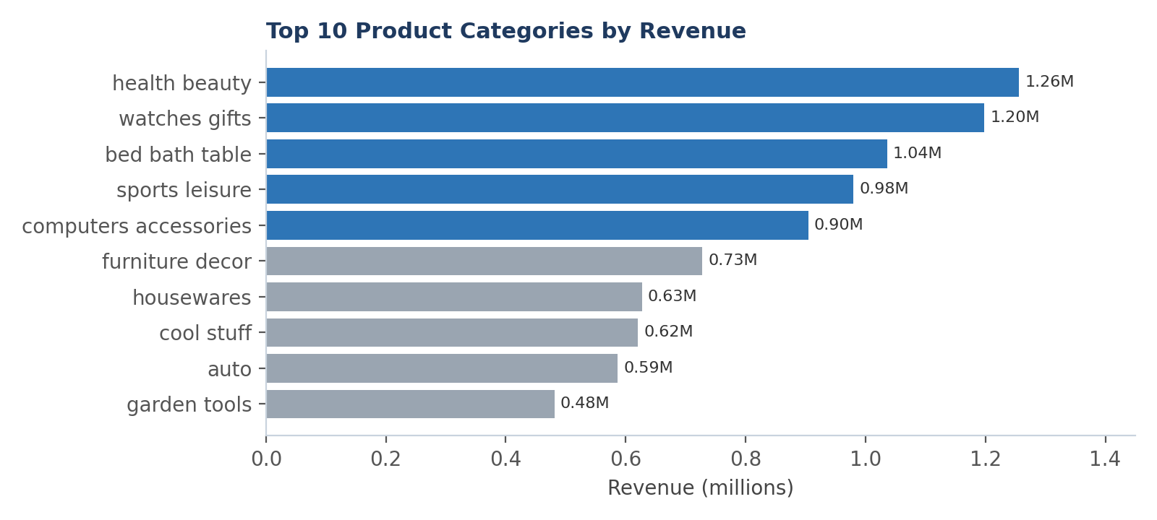
- The top 5 of 71 categories account for 40% of revenue.
- watches_gifts has the highest unit price (about 200) with 5,970 units, while bed_bath_table has the highest volume (11,097 units) at a lower price: two different models, value versus volume.
- The best single product earned only 63,885, so no single product dominates.
INSIGHT Revenue is spread across many categories, which lowers risk. The improvement opportunity is in high-volume, low-price categories.

Customers & sellers (Q3 & Q6)
3.0%  REPEAT CUSTOMERS  2,888 customers | 1.03  ORDERS / CUSTOMER  average | 0.5%  TOP 10 CUSTOMERS  of revenue

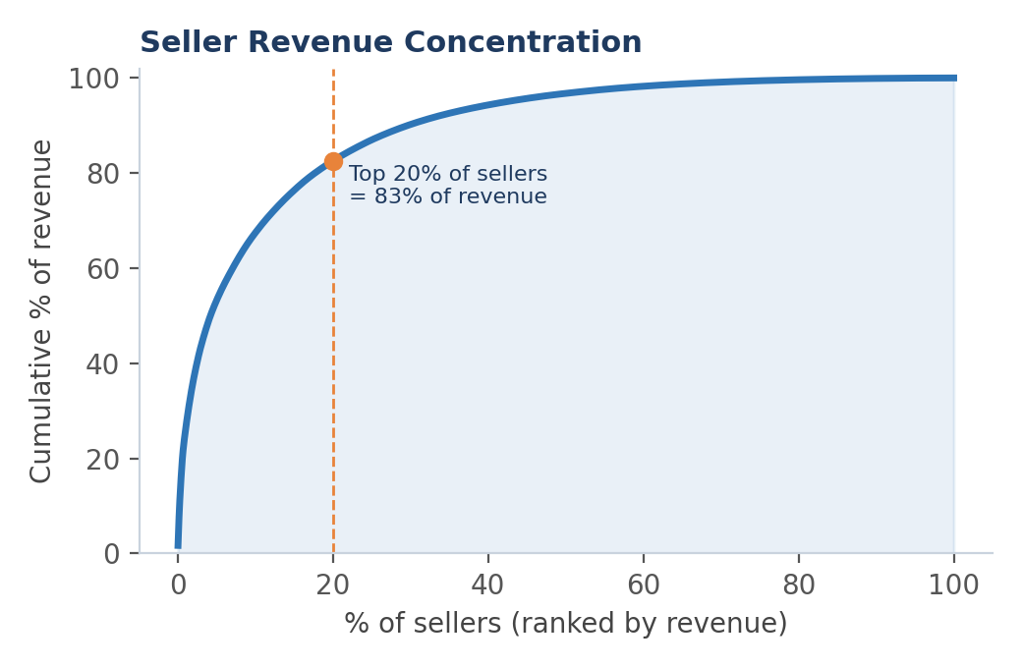
- The top 10 sellers earn 13.2% of revenue, the top 1% (30 sellers) 25.8%, and the top 20% 82.5%.
- The top seller earned 229,238 from 1,155 units. The second earned 222,776 from only 410 units (high unit price), so Revenue must always be read together with Items Sold.
INSIGHT There is no dependence on any single big customer, but retention is very weak. On the seller side there is clear concentration (a Pareto pattern).
RECOMMENDATION Lifting repeat purchases to even 5% is the cheapest path to growth, since it needs no new customer acquisition cost.

Payment methods (Q7)
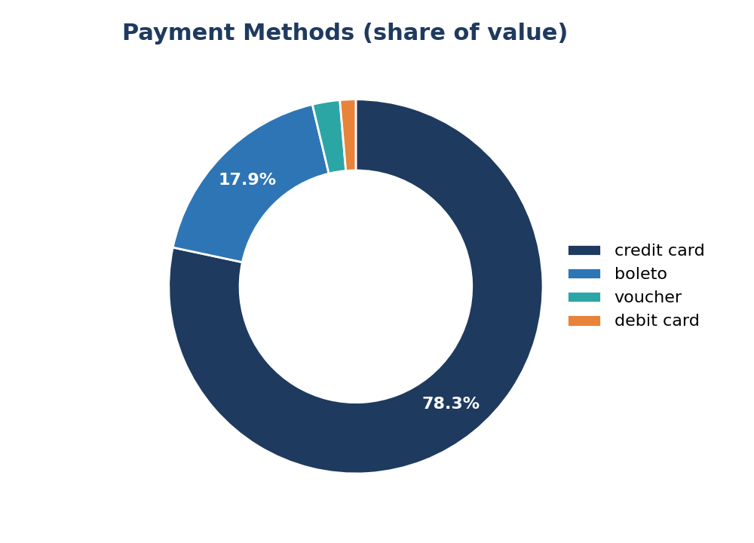
Method | Value | Share | Avg installments
credit_card | 12,542,084 | 78.3% | 3.5
boleto | 2,869,361 | 17.9% | 1.0
voucher | 379,437 | 2.4% | 1.0
debit_card | 217,990 | 1.4% | 1.0

INSIGHT Credit card with installments drives sales. Boleto (a Brazilian cash-based payment) is second and delays payment confirmation.

Delivery & satisfaction (Q4 & Q5)
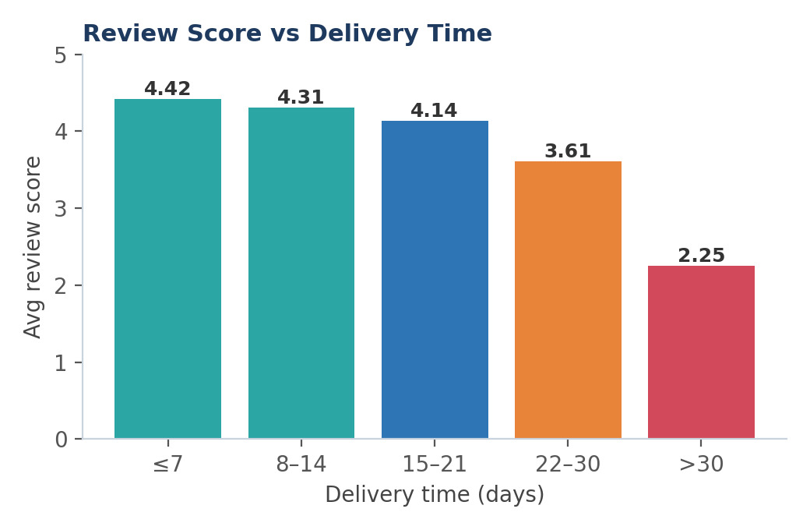 | 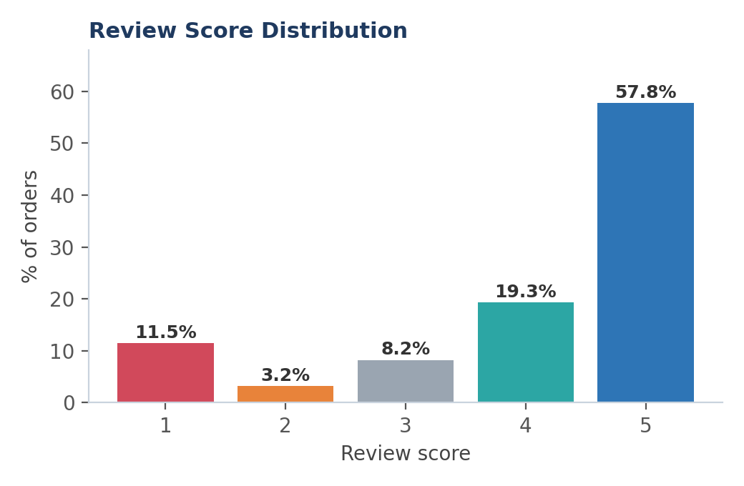
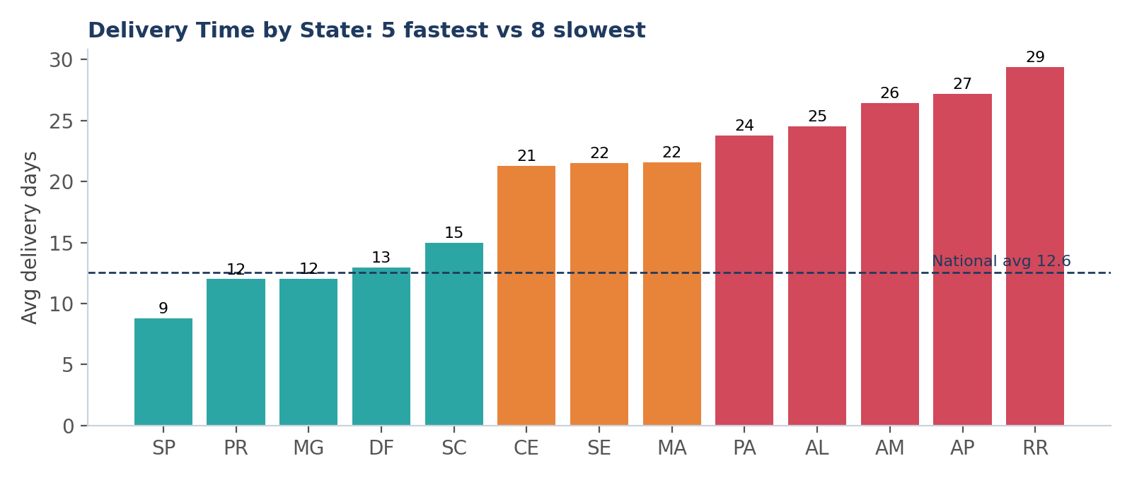
- Overall rating is 4.09: 57.8% are five-star, but 14.7% are poor (1–2 stars).
- Ratings fall steadily with each extra week of delay: 4.42 (7 days or less) down to 2.25 (over 30 days).
- Average delivery is 12.6 days with 8.1% late. SP is the fastest state (8.8 days) while the North and Northeast take 21 to 29 days. AL has the highest late rate (23.9%).
INSIGHT Delivery is the strongest driver of satisfaction, and the North problem is geographic and logistical rather than a seller problem.
RECOMMENDATION Reset the estimated delivery date in remote states so it reflects reality, because customers penalise missing the promised date more than a long duration.

Geography (Q9)
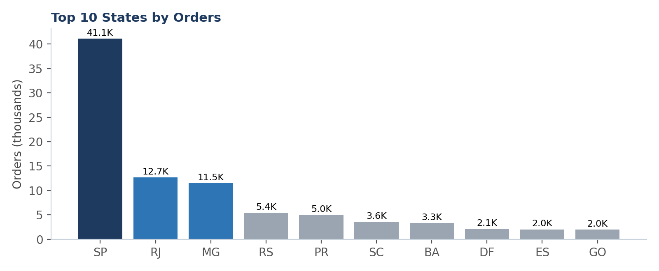
- SP 41,127 orders (41.9%), RJ 12,698 (12.9%), MG 11,496 (11.7%). The top 5 states hold 77% of orders.
INSIGHT Orders cluster in the Southeast, where population density and logistics are strongest, which is also why delivery performance is best there.

04 Recommendations
Priority | Recommendation | Evidence from the analysis | KPI to track
High | Reset estimated delivery dates in the North and Northeast | 2.57 rating when late; AL has 23.9% late | Late Deliveries %
High | Customer retention programme (repeat-purchase coupon after delivery) | 97% one-time buyers | Avg Orders per Customer
Medium | Expand in RS, PR and SC | SP+RJ+MG = 66.5% of orders | Share of orders outside top 3 states
Medium | Support mid-tier sellers and improve their visibility | Top 20% = 82.5% of revenue | Active Sellers
Medium | Prepare stock and shipping before November | Black Friday 2017 peak | November revenue
Low | Incentives for electronic payment instead of boleto | 17.9% boleto | credit_card share

05 Dashboard Guide
The dashboard has 4 pages at 1920×1080, with a side navigation menu and Year and Month slicers:
Page | Content
Overview | Navigation page with buttons to the other pages
Sales & Payments | Cards (Revenue, Orders, AOV, YoY%), monthly and yearly revenue, order statuses, payment methods and installments
Products, Sellers & Customers | Cards (Items Sold, Active Sellers, Unique Customers), category treemap, top products, seller table, top customers
Delivery, Satisfaction & Geography | Cards (Review, Late %, Delivery Days, Freight), Brazil map, delivery days by state, orders by state

Measures (DAX)
Measure | Purpose
Total Revenue / Total Orders / Avg Order Value | Sales KPIs
Revenue YoY % | Growth versus the same period of the previous year
Payment Value / Avg Installments | Payment analysis
Items Sold / Active Sellers | Sales volume and seller base
Unique Customers / Avg Orders per Customer | Customer base and repeat rate
Avg Review Score | Customer satisfaction
Avg Delivery Days / Late Deliveries % / Avg Freight | Delivery and shipping performance

Limitations
- The data effectively ends in August 2018 and 2016 is partial, so comparisons must use the same period.
- The data comes from Olist only and is anonymised, so results should not be generalised to the whole Brazilian market.
- Figures were computed from the CSV files using the same logic as the measures. If a card differs slightly, check the Year and Month slicers.

